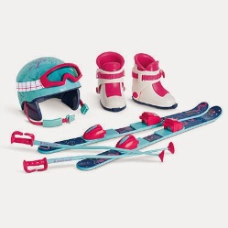  BOLTON VALLEY SKI RESORT  For Federal Employees and their spouse and children.  www.boltonvalley.com/tickets-passes-rentals/seasons-passes/Corporate-Season-Passes  PROMO CODE: CORPVTFEDERAL  (802) 434-6813 | ASIAN BISTRO  Williston and Winooski  10% off your bill  121 Connor Way - Williston  (802) 878-8878  25 Winooski Falls Way - Winooski  (802) 655-9800 | 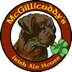  28 Walnut Street  Williston  20% Discount on one entrée or appetizer per visit  (802) 857-5908
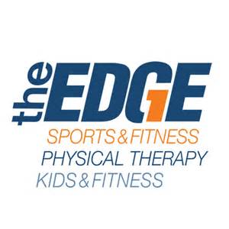  Essex, South Burlington, Williston  35% off any yearly membership or  20% off short term or monthly memberships  One membership includes five Edge locations | Betty’s Flower Basket  10% Discount  9 Bank Street  Saint Albans | 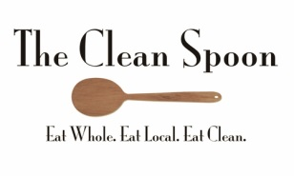  Every Tuesday 10% off  34 South Main Street  Saint Albans  (802) 249-0058
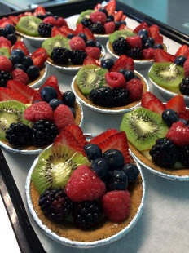
Madeleine’s Bakery
2 extra cookies when you buy 6.
5 Southerberry Drive Unit 101, Route 7
Milton

