Clean Shopping List
Pantry:
Organic Spices - I find the best way to get affordable organic spices is to buy in bulk at health food stores or co-ops and store in glass jars.
Corn Starch
Whole Wheat Bread Flour- As with the spices, the most affordable organic flours are usually in the bulk bins at health food stores.
Whole Wheat Flour
Oat Flour
Baking Powder
Baking Soda
Corn Meal
Almond Meal
Grain Sweetened Chocolate Chips
Various Nuts
Various Nut Butters
Flaked, Unsweetened Coconut
Unsweetened Almond Milk
Molasses
Agave Nectar
Honey
Quinoa
Brown Rice
Sweet Potatoes
Onions
Safflower Oil
Coconut Oil
Grape Seed Oil
Canned tomatoes
Freezer:
Various Berries
Smoothie Packets - Frozen berries, bananas, greens, etc. in individual serving sizes. Just add liquid.
Corn
Any out of season veggies- Try to find veggies stored in non-plastic packaging
Homemade Stocks
Fridge:
Greens- Kale, Spinach, Swiss Chard, etc. All of these are interchangeable
Meats - Grass fed beef, free range chicken, etc. The cleaner the animal, the cleaner the person.
Fresh Fruits and Vegetables- Your best bet is always what's in season. Fresh=healthy
Edamame- I love the Costco's organic Edamame. Pre-cooked and lightly salted. Great snack. However, make sure you buy Edamame that says Non-GMO as Soy is one of the most modified foods.
Natural Condiments- It's easier than you think to make your own ketchup and such. Try it!
Yogurt and Cottage cheese- Buy plain and add your own natural flavorings. These items are full of protein, but "light" or "low-fat" versions are packed with chemicals.
Sprouts/Mung Beans
Tomatoes
Fat Free Milk

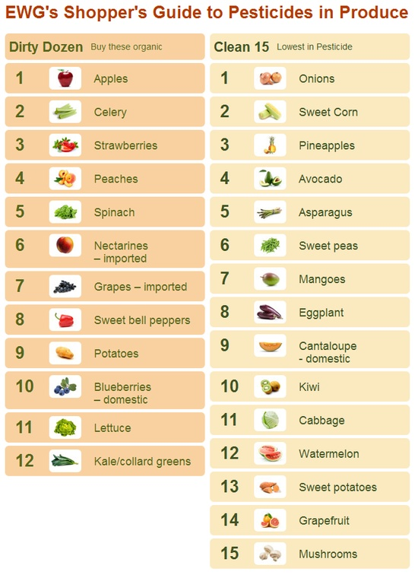

Super foods. Best bang for your buck.

Lemon- Supports weight loss, has antiviral and antibacterial properties, cleanses the liver, alkalizing properties,
Coconut Oil- Boosts immunity, lowers bad cholesterol, positively effects hormones and thyroid which aid in weight loss,
Ginger- Promotes blood flow, assists in nutrient absorption. Aids in digestion and immunity. Shown to induce destruction of ovarian cancer cells.
Turmeric- Will actually KILL cancer cells. Studies show you should consume about a tsp a day to prevent cancer and those with cancer should consume a TB a day.
Fermented Foods- Easier to digest, aids in absorption of nutrients, and promotes good bacteria growth in your digestive system while pushing out the bad.
Apple Cider Vinegar- Kills fungus and candida in the digestive system, eliminates joint pain, boosts immunity, shown to lower blood pressure and bad cholesterol.
Quinoa- A complete protein containing all 9 essential amino acids. Contains double the fiber of most grains and contains iron and magnesium.
Braggs Amino Acids- Amino acids are the building blocks of protein. Protein is present in every cell of the body and vital to EVERY bodily function.
Blueberries- Antioxidant superstar. Also and anti-inflammatory and can reduce the risk of heart disease.
Pumpkin Seeds- Loaded with minerals and the most alkalizing seed. Good source of zinc and Vitamin K.
Tea- If you don’t like it, learn to! There are so many teas out there and each one does something for the body. Start replacing some of your drinks everyday with tea. Come up with your favorite tea drink and go with it. Example: Dandelion Root tea, a slice of ginger, a tsp. of raw honey, and half the juice of a lemon. Delicious and healthy.

Super bad foods. Keep them out of your mouth and body!

Sodium Nitrate- You fill find this in most cured meat, hot dogs, bacon, ham, etc. They aid in preserving but the main goal is to turn the meat pink so it’s more appealing to the eye. Nitrate are a KNOWN carcinogen. You can fine bacon, hot dogs, and such that are nitrate free. Try the Applegate line.
Excitotoxins- The biggest offender is MSG, or monosodium glutamate. Sadly, it’s in a ton of food. Clean eating can eliminate most of this because it’s found in processed food and does not occur in nature. The purpose of these is to “excite” your taste buds. After it excites your nerved, it causes nerve cells to die.
Margarine and other Hydrogenated Oils- May as well be plastic. Clogs arteries. Enough said.
Artificial Sweeteners- Inhibits weight loss, makes you feel less full and encourages you to eat more. They are also linked to cancer and diabetes. Your sweet receptors think you are eating sugar which will product an unnecessary insulin spike in your body. This can lead to insulin resistance.

Clean Eating Recipes

Clean Meatloaf

Meatloaf
1 lb of organic, lean grass fed ground beef
4 slices of whole wheat bread ground into crumbs (should be about 2 cups of soft breadcrumbs)
2 farm fresh eggs, beaten
1 tsp kosher salt
1 tsp Italian spices
2 TB of fresh parsley, chopped fine
½ tsp pepper
1 garlic glove, minced
¾ cup of unsweetened almond milk (any milk can be used here)
¼ cup onion, diced
Preheat the oven to 350 degrees. Grease the inside of a bread loaf pan with coconut oil.
In a large bowl, mix all ingredients by hand. Be careful to mix until all items are just combined. If you over mix, the meatloaf will be tough.
Place the meat mixture into the loaf, and bake for about 1 hour. You want the meatloaf to be crisp on top and the internal temp to be 160 degrees.
I served this meal with mashed cauliflower and steamed kale.
Makes about 6 servings.

Whole Wheat Bread
3 cups whole wheat bread flour
2 1/4 tsp of rapid rise yeast
1 tsp salt
1 cup very warm water (just warm enough so it's almost uncomfortably warm)
2 TB of honey
1/4 cup melted coconut oil or grape seed oil
Set your bread machine to just the dough setting. You can cook in your bread machine, but I prefer to bake in my oven. The form and outer texture is better.
Put the water, salt, yeast, and honey into the machine. Let sit for about 5 minutes to let the yeast start to work.
Next add the flour and oil and push start!
An hour and 1/2 later, take the dough out and onto a flour surface. Stretch out and fit to a normal sized bread loaf pan. Set in a warm place for about 30 minutes and allow to rise. Brush top with egg wash and bake in a preheated oven at 350 degrees for about 30 minutes.
Take out of pan as soon as it comes out of the oven and let cool on rack.

Banana Quinoa Pancakes
1 cup cooked quinoa
3/4 cup whole wheat flour
1/2 tsp cinnamon
1/2 tsp nutmeg
1 1/2 teaspoons baking powder
1 tsp coarse salt
2 large egg whites
1 egg
1/3 cup vanilla almond yogurt
2 tablespoons of unsweetened almond milk
2 tablespoons honey
1 teaspoon pure vanilla extract
2 large very ripe bananas, pureed
In a medium bowl, whisk together flour, spices, baking powder, and quinoa. In a large bowl, mix together the remaining ingredients. Slowly stir in the dry ingredients. Stir until just combined.
Melt a little coconut oil on a preheated skillet and scoop on about 1/4 cup of the mixture. Cook about 2 minutes per side. You will know to flip when you start seeing bubbles form. This should make about 12 pancakes.
These would be great with some chocolate chip, coconut, or berries added.

Mexican Quinoa Chicken Salad
1 cup shredded cooked chicken
1 cup cooked quinoa
¼ cup salsa
1/2 cumin
½ cup shredded cabbage
1 TB chopped fresh cilantro
Juice of 1 lime
¼ cup black beans (drained and rinsed)
¼ cup of frozen corn
Combine all ingredients in a bowl, toss, and enjoy! I serve this over a bed of spinach or mixed greens.

Perfectly Cooked Quinoa
2 cups quinoa
3 cups water
Add quinoa and water to medium sized sauce pan and bring to a boil. Once boiling, turn down the heat to low and let simmer for about 20 minutes, stirring several times during the cooking process.
Keep in your fridge to add to recipes all week!

Preparation Sunday!

To eat clean you have to prepare! No exceptions

Example To Do List:

Boil or roast 2 lbs of chicken breast or a whole chicken

Cook 2 cups of Quinoa

Go Chop Crazy! Pre chop a bunch of veggies and fruit

Make Smoothie bags to toss in the blender and go

Make up snacks like cheese and apples, nuts portioned out, roasted chickpeas, granola bars, etc.

Make “base” salads. Mix together a big bag of greens and veggies. Throughout the week you can add fruits, nuts, seeds, chicken, etc to them to make salads

Make your own dressing! Store in a canning jar for the week

Make some breakfast wraps and freeze for easy reheating

Have some healthy “splurges” at hand. (My personal splurge is strawberries drizzled (not dipped) with dark chocolate)

Place an order to The Clean Spoon

